Template for the P&T Dossier - Professorial Faculty
*delete this page when finalizing your dossier

General guidance:
- Use the headings/numbering system as shown in black font
- Recommend use of Times New Roman Font and size 12 pt.
- Use Left justify the headings/numbering system
- Add page numbers to the PDF version, not the Word version
- If a header is not relevant to you, indicate N/A. Do not omit the header.
- Comments are provided throughout the template.
- Examples are shown where accessible.
- The CV should be fully consistent with OSU guidelines presented in the Faculty Handbook (Dossier Preparation Guidelines). https://academicaffairs.oregonstate.edu/resources-policies-legislation/policies-and-resources/promotion-and-tenure-guidelines
PROMOTION (AND TENURE) VITA

Faculty name

Department name

College of Forestry

Promotion to X

Month Year

FORM A INSERTED INTO PDF HERE

CONFIDENTIALITY WAIVER INSERTED INTO PDF HERE

POSITION DESCRIPTION(S) INSERTED INTO PDF HERE
Include all PDs since last promotion
Consider using the OSU table below, if necessary

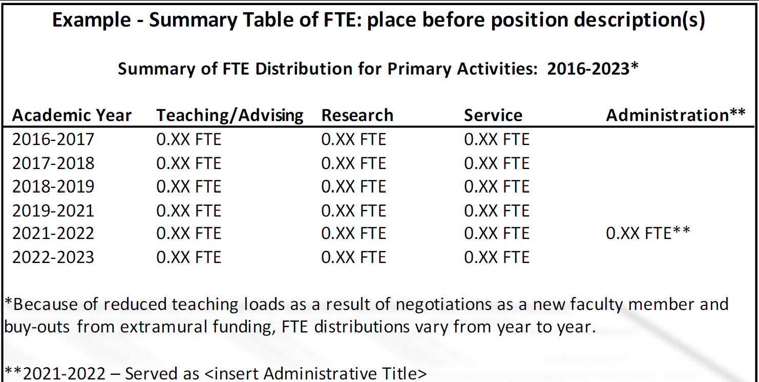

CANDIDATE STATEMENT

PART A: The candidate must include a statement (three-page maximum, single-spaced, 12- point font, one-inch margins) that addresses the individual's contributions in their primary assigned duties (e.g., teaching and advising; scholarship and creative activity; service and/or other assignments), including DEI. DEI efforts can be reported in the context of position duties as applicable or as a separate category.

PART B: An optional COVID-19 impact statement may be included (one page maximum, 12 point font, one inch margins). This statement is in addition to the 3-page candidate statement and does not impact the length of that statement. COVID-19 impact statements describe the impact of the pandemic on the ability to perform duties in the position description. Impacts may include the following examples: personal circumstances that impede work, lack of access to research facilities and sites, inability to collect data, publication delays, cancelled conferences and seminars, or other circumstances attributable to the changed landscape of working under pandemic conditions.

STUDENT & PEER LETTERS OF EVALUATION
INSERTED INTO PDF HERE

PART A: The purpose of the student evaluation letter is to document the student perspective of the candidate’s effectiveness as a teacher and advisor. To provide the university with a consistent source of information for the process, the unit P&T committee and the unit supervisor should endeavor to obtain individual student letters using the process outlined in the Dossier Preparation Guidelines.

PART B: Peer evaluations should be based on a review of course syllabi, texts, assigned reading, examinations, class materials, and other assessments such as attendance at lectures as appropriate for the field and subject area. Peer teaching evaluations should be systematic and on-going, following unit guidelines for peer review of teaching. A letter from the peer teaching review committee that summarizes all peer teaching reviews over the evaluation timeframe should be included in the dossier. Faculty are strongly encouraged to seek periodic peer teaching reviews and work with their supervisors to schedule these reviews on a timely basis.

For Extension faculty, this is where to include your Peer Teaching Evaluations (PTE).

ADMINISTRATIVE LETTERS OF EVALUATION
INSERTED INTO PDF HERE

- Departmental Faculty Committee Letter
- Department Chair or Department Head Letter
- Letters from Other Administrators with Supervisory Responsibility
- College or Unit Promotion and Tenure Committee's Letter
- Dean, Director, Vice President, or Vice Provost's Letter

PROMOTION (AND TENURE) VITA

- EDUCATION AND EMPLOYMENT
  - Education
20xx, Ph.D., Dept. name, University name
Major:
Advisor:
Dissertation title:

19xx, M.S., Dept. name, University name
Major:
Thesis title:

19xx, B.S., Dept. name, University name
Major:

  - Employment History

20xx- present | Title, Dept. of xx, Oregon State University, City, OR
20xx-20xx | Title, Dept. of xx, xx University, City, State
20xx-20xx | Title, Dept. of xx, xx University, City, State

- TEACHING, ADVISING AND OTHER ASSIGNMENTS
  - Instructional Summary
Credit Courses at OSU
Course  Number | Credits | Course Title | Term | Number of  Students
Prior to last promotion (or prior to OSU)

Non-Credit Courses and Workshops

Total no. events | No. of events  (organized or co-organized) |  |  | No. of presentations in non- credit teaching events |  |  | No. of invited events | Total no. of attendees
Total no. events | Regional | National | Intl. | Regional | National | Intl. | No. of invited events | Total no. of attendees
Below list activities occurring before last promotion (or prior to OSU)

Curriculum Development

Course number | Institution | Course description link if applicable | New or revision | In load or overload | DEI
Courses developed prior to last promotion (or hiring) at OSU

  - Student (eSET) and Participant/Client Evaluation (CET)
Undergraduate Courses Taught
Question 2: The instructor's contribution to the course was
Year | #  Resp onses | Very Poor  % | Poor  % | Fair  % | Good  % | Very Good  % | Excell ent % | Unabl e to  rate % | Mean | Median
COF 5-YR AVG.
W21 DPT xxx
S21 DPT xxx
F21 DPT xxx
S22 DPT xxx
F22 DPT xxx
F23 DPT xxx
F24 DPT xxx
W25 DPT xxx

Graduate Courses Taught
Question 2: The instructor's contribution to the course was
Year | #  Resp onses | Very Poor  % | Poor  % | Fair  % | Good  % | Very Good % | Excelle nt % | Unable to rate  % | Mea n | Median
COF 5-YR
AVG.
S21 DPT xxx
F21 DPT xxx
S22 DPT xxx
F22 DPT xxx
W24 DPT xxx

  - Advising

Graduate Students and Postdoctoral Trainees

Major Professor
[one sentence summary, e.g.: I have served or am serving as major professor for a total of x graduate students during my time at OSU. X PhD students of this total have graduated so far.]

Student | Degree | Program | Advisor from | Expected or actual graduation term
Advising prior to last promotion (or hiring) at OSU

Other Graduate Student Committee Service
[one sentence summary, e.g.: I have served on a total of x student committees including x as a committee member and x as graduate council representative.]

Student | Degree | Program | Expected or actual graduation term
Service prior to last promotion (or hiring) at OSU

  - Other Assignments

Supervision of Interns, Postdoctoral Scholars, Visiting Scientists, and/or Other Research Staff
[one sentence summary, e.g.: I have managed x faculty research assistants continuously and x lab technicians for approximately x months/years. I have hosted x international visiting scholars through various programs and advised x postdoctoral scholars.]

Scientist/Staff | Role | Description | Period of Supervision
Supervision prior to last promotion (or hiring) at OSU

- SCHOLARSHIP AND CREATIVE ACTIVITY
  - Peer-reviewed Publications

Timeframe | Refereed journal articles | Book chapters | Extension publications | Other peer reviewed materials
Since last promotion
Prior to last promotion
Prior to OSU
Total

Refereed Publications [list refereed publications, e.g.:]
19. Gerald Presley and Matthew Konkler (2024). Copper migration from treated wood garden boxes into soil and vegetable biomass Part I: The first two growing seasons after installation, Wood and Fiber Science, 56(2), 91-99.
The second author is my research assistant. My contribution: 75% (collecting data, funding, writing, editing)
- Gerald Presley and Matthew Konkler (2024). Copper migration from treated wood garden boxes into soil and vegetable biomass Part I: The first two growing seasons after installation, Wood and Fiber Science, 56(2), 91-99.
The second author is my research assistant. My contribution: 75% (collecting data, funding, writing, editing)

Peer-reviewed Publications in Review
[list]

Non-refereed Publications
[list]

  - Presentations

Timeframe | Within region | National | Int’l | Total | No. invited
Since last promotion or hiring at OSU
Total

*Presenter, oral #Presenter, poster +Invited

[list, e.g.: Iman Rashidijouybari, Matthew Konkler, Kaelin Quigley, and Gerald Presley* (2024). Exploring the Migration of Creosote in Freshwater Environments: A Study on Treated Wood Immersion, International Research Group on Wood Protection 55th Annual Meeting, May 19-23, 2024, Knoxville, TN, Oral.]

  - Sponsored Research

Total Funding by Category

Funding Type | $ Amount OSU/Dept  portion | $ Amount My Share | % of Total of  My Share
Total Competitive External
Total Competitive Internal
Total Non-competitive External
Total Non-competitive Internal
Total Gift
Total Technical Services
Total Cooperative
Grand Total

Success Rates for Competitive Proposals
Funding Type | Proposals  Declined | Proposals  Funded | Success  Rate
Total Competitive External as P.I.
Total Competitive External as Co-P.I.
Total Competitive Internal as P.I.
Total Competitive Internal as Co-P.I.

[list grants, contracts, joint ventures, gifts, etc.]
e.g.: 1. PI (Arbor Wood Co.): John Heyesen and Kelly Bartz, Subaward PI (OSU): Gerald Presley. USDA Forest Service Wood Education and Resource Center. Standardization of Thermal Modification as a Wood Protection System against Fungal Decay and Termites, September 1, 2022-August 30, 2025. OSU Share: $109,509, My Share: $109,509, 100%.

  - Intellectual Property

[e.g. 1. Robert Macias Naranjo, Gerald Presley, Islam Hafez, and John Simonsen. Draft/829/24 (2024). Multipurpose Thermochemical Conversion Unit- MTech, Invention Disclosure, 33 pp.]

  - Use and Licensing

[e.g.: License to XYZ Corporation of US Patent # 123,456,789 generated $250,000 in royalties (2020-to date). Technology enables farmers to increase crop yield by 12%, over 10,000 farms are actively using technology]

  - Entity Creation

[e.g.: Professor Smith’s Spinout company Recycled Processes received $2.5M in Series A funding from industry leaders X, Y and Z
o Currently employs 10 people (as of July 30, 2024) include 6 OSU alums
o Enabled by OSU license of US Patent # 123,456,789
o Target market is XYZ and will impact approximately 100,000 consumers]

  - Other

[e.g.: The Merchant Magazine, WWPI Special Issue. “Western treaters support PTW research”. April 2022]

- SERVICE
  - University Service
  - Service to the Profession
  - Service to the Public (professionally related)
  - Service to the Public (non-professionally related) *optional
  - Service Impact *if service is a significant portion of the FTE

- AWARDS
  - National and International Awards
  - State and Regional Awards
  - University and Community Awards

LETTERS OF EVALUATION
INSERTED INTO PDF HERE

- Solicited Letters of Evaluation from Outside Leaders in the Field (6 minimum, 8 maximum)

OTHER MATERIALS INSERTED INTO PDF HERE
*optional

CANDIDATE’S SIGNED STATEMENT

